4.4 Algorithm Evaluation Results
The meal-planning algorithm was evaluated as a two-stage planning process consisting of deterministic candidate filtering, Stage 1 candidate ranking, and OR-Tools CP-SAT weekly assignment optimization. The planner first removes unsafe or incompatible recipe candidates, ranks and reduces the feasible candidate pool, and then solves a weekly 0-1 assignment model in which each recipe-slot decision indicates whether a recipe is assigned to a meal slot. The model enforces one recipe per slot, meal-type compatibility, allergy and restriction safety, configured budget limits, repetition limits, and adjacency rules. The objective function penalizes nutrition deviation, repetition, preparation burden, and related soft criteria while rewarding practical signals such as pantry overlap and diversity where configured.
The implementation is best described as a MILP-formulated 0-1 weekly assignment model solved using OR-Tools CP-SAT, or more simply as deterministic filtering followed by OR-Tools CP-SAT integer optimization. It should not be described as a pure classical MILP solver because the implemented solving mechanism is CP-SAT. In the final system, LightGBM support is assistive to Stage 1 ranking when a valid model artifact is configured; hard safety filters and CP-SAT constraints remain the authority for final plan selection.
Table 4.3
Benchmark Scenario Descriptions
Scenario | Description | Main Constraint Tested
S1 Base | Standard profile without added restrictions. | General 21-slot generation, nutrition deviation, and runtime
S2 Budget and No Pork | Profile with PHP 1,000 weekly budget and No Pork restriction. | Hard budget cap and restriction filtering
S3 Vegetarian and Lactose Intolerant | Profile with combined dietary restrictions. | Restrictive candidate pool handling
S4 Pantry-Aware Case | Profile with pantry ingredients and No Beef restriction. | Pantry-overlap ranking and grocery practicality
S5 Resilience/Stress Case | Profile with an intentionally infeasible PHP 20 weekly budget. | No-safe-plan handling, hard budget boundary, and safe failure behavior
Table 4.3 describes the benchmark conditions used to evaluate the current PCOSina planning workflow. The scenarios were selected to represent ordinary use, budget pressure, combined dietary restrictions, pantry-aware planning, and a deliberate infeasibility case used to verify that the system returns structured no-safe-plan feedback instead of forcing an unsafe recommendation.
Table 4.4
Final-Build Runtime and Safe Completion Results
Scenario | Average Runtime (s) | Candidate Pool (pre/post) | Planner Result | Safe Completion Outcome
S1 Base | 0.6309 | 202 / 120 | Success | 21 / 21 slots, 0 hard violations
S2 Budget and No Pork | 1.0768 | 177 / 120 | Success | 21 / 21 slots, hard budget cap met
S3 Vegetarian and Lactose Intolerant | 0.6988 | 102 / 102 | Success | 21 / 21 slots, 0 hard violations
S4 Pantry-Aware Case | 1.1201 | 222 / 120 | Success | 21 / 21 slots, 38 pantry-overlap matches
S5 Resilience/Stress Case | 3.2940 | 177 / 120 | No-safe-plan | No unsafe plan returned; infeasible hard budget preserved
Table 4.4 summarizes the observed final-build local benchmark results using three runs per scenario. The first four scenarios produced complete 21-slot plans with zero observed hard-safety violations. The stress scenario was intentionally infeasible because of the PHP 20 weekly hard budget cap; the planner correctly returned a no-safe-plan result rather than relaxing the hard budget or producing a prohibited recommendation. These results should be interpreted as system benchmark evidence, not as a production latency guarantee, because runtime can change with deployment environment, database configuration, network conditions, candidate pool size, and solver settings.
Table 4.5
Nutritional Quality and Constraint Outcome Comparison
Scenario | Average Calorie Deviation | Average Macro Deviation | Budget Result | Pantry Result | Hard-Constraint Outcome
S1 Base | 576.00 | 30.85% | Not budget constrained | 0 matches | 0 hard violations
S2 Budget and No Pork | 740.67 | 40.34% | PHP 1,000 cap met exactly | 0 matches | 0 hard violations
S3 Vegetarian and Lactose Intolerant | 691.00 | 35.90% | Not budget constrained | 0 matches | 0 hard violations
S4 Pantry-Aware Case | 563.00 | 30.85% | Not budget constrained | 38 pantry-overlap matches | 0 hard violations
S5 Resilience/Stress Case | Not applicable | Not applicable | PHP 20 cap infeasible | Not applicable | No-safe-plan returned
Table 4.5 indicates that the proposed planner preserved hard-constraint safety across the evaluated benchmark scenarios. The completed plans still show calorie and macronutrient deviation, which is expected in a constrained weekly meal-planning problem with cultural, budget, pantry, and dietary requirements. Therefore, the planner should be interpreted as a decision-support and optimization method rather than a guarantee of perfect nutrition-target satisfaction or clinical effectiveness.
The current adaptive retry policy is narrower than the earlier relaxation-ladder description. It retries nutrition tolerance and recipe-repeat limits only, while allergies, exclusions, dietary restrictions, slot validity, pantry safety filtering, and configured hard budget constraints remain fixed.
The results support the importance of explicit hard-constraint enforcement. Across feasible benchmark scenarios, the current planner produced complete weekly plans without observed hard-constraint violations. When the configured constraints made a safe complete plan impossible, the system returned structured no-safe-plan feedback instead of forcing an unsafe automatic recommendation.

4.5 Pantry, Grocery, and Budget Evaluation
Pantry, grocery, and budget behavior were evaluated separately because these features affect practical usability as much as solver optimality. The current implementation is pantry-aware rather than fully pantry-constrained: pantry overlap can influence ranking and grocery guidance, but it does not prove that a user can cook the full plan using pantry items only. Budget handling is stricter when a weekly cap is configured, because the solver treats the budget as a hard cap. Therefore, the thesis interprets pantry support as pantry-aware guidance rather than guaranteed pantry-only feasibility.
Table 4.6
Pantry, Grocery, and Budget Evaluation Summary
Computation Area | Observed System Behavior | Interpretation
Pantry-overlap behavior | S4 recorded 38 pantry-overlap matches across the completed plan; pantry tokens such as chicken, egg, garlic, and tomato can influence ranking. | Pantry supports ranking and grocery guidance, but it is not full pantry-only feasibility.
Grocery deficit and guidance | The grocery screen consolidates recipe ingredients and marks pantry-covered items using item-name or token matching. | The feature supports shopping guidance, but coverage depends on item naming and user pantry data.
Estimated price computation | Example pricing rules include egg estimated at PHP 7 per piece; recipe and weekly plan costs are planning estimates. | Prices are estimated for planning and should not be treated as actual real-time market prices.
Budget behavior | S2 produced a complete plan at the PHP 1,000 estimated cost cap, while S5 returned no-safe-plan under an infeasible PHP 20 cap. | Budget is enforced when configured; an infeasible budget is not relaxed into an unsafe or prohibited plan.
Thesis interpretation | Pantry and budget features improve practical meal planning but remain approximate where estimates and user-entered pantry data are involved. | Interpret as pantry-aware and budget-aware guidance, not guaranteed market-price or pantry-only proof.
Table 4.6 shows that pantry and budget features support practical meal planning while preserving important limitations. Pantry data can improve ranking and reduce unnecessary grocery suggestions, but matching remains approximate and user-dependent. Budget constraints, by contrast, are enforced as hard caps when configured, as shown by the successful PHP 1,000 case and the no-safe-plan result under the infeasible PHP 20 stress case.

4.6 Offline-First and Performance Evaluation
Offline-first behavior was evaluated in terms of continuity rather than claiming that every function is fully offline. PCOSina stores important user-facing information locally so that saved plans, pantry data, grocery guidance, and progress records can remain accessible after they have been created. However, new optimized meal-plan generation may still depend on backend availability because the current planner uses the backend CP-SAT service and optional worker or queue execution path.
Table 4.7
Offline-First and Performance Evaluation Summary
Area | Available Evidence | Interpretation
Saved data continuity | Saved profile, meal-plan, pantry, grocery, and progress information are supported by local persistence. | Users can continue viewing created information offline.
New plan generation | Optimized generation uses the backend CP-SAT planning service and optional worker or queue path. | New optimized plans should not be claimed as fully offline.
Observed final-build runtime | Current local evidence averaged 0.6309 s to 1.1201 s for successful scenarios and 3.2940 s for the no-safe-plan stress case. | The current solver path completed quickly in local validation, but runtime depends on environment.
Earlier development slow runs | Earlier observed runs of 207,816 ms and 188,249 ms showed a performance bottleneck before optimization work. | Historical evidence explains why candidate-pool limits and backend optimization were needed.
Performance interpretation | Later optimized runs and final-build evidence show substantial improvement over earlier slow runs. | Treat as system performance evidence and repeat in the target deployment environment before final production claims.
Table 4.7 supports the claim that PCOSina has offline-first continuity and that performance improved after optimization work. The observed performance improvement supports the feasibility of the optimized backend workflow. However, runtime can be affected by deployment environment, network conditions, database configuration, candidate pool size, and solver settings, so final release testing should be repeated using the final evaluation build and target devices.

4.7 Stage 1 Ranking and Safe-Failure Evidence
This subsection records the assistive Stage 1 learning evidence separately from the final optimizer. The positive label means a candidate was selected by the solver; a non-selected candidate is negative. The ML ranker only changes candidate ordering after deterministic safety filtering and cannot override allergies, excluded ingredients, hard budget ceilings, pantry feasibility, nutrition bounds, repetition rules, or explicit hard preferences.
Table 4.8
Stage 1 Ranking and No-Safe-Plan Evidence Summary
Evaluation item | Evidence / result | Source | Interpretation
LightGBM dataset | 74,112 rows from 360 requests and 60 users | ml/offline_training/artifacts/model_v1/training_metrics.json | Current model_v1 artifact using solver-labeled selected/non-selected candidate rows.
Split and leakage control | Train/validation/test rows: 60,319 / 7,350 / 6,443; split by request_id using hash(request_id) modulo 10 split | Dataset manifest inside model_v1 artifact | Request-level splitting reduces leakage risk for ranking evaluation.
LightGBM discrimination | Validation AUC 0.9545; Test AUC 0.9373 | Model V1 metrics | The ranker separates solver-selected candidates from non-selected candidates, but it is not a safety authority.
Ranking quality | Test NDCG@10 0.9211; Test MAP@10 0.6779 | Model V1 metrics | Selected candidates are generally placed high in the Stage 1 ordering.
Uplift vs heuristic ranking | Test +0.0373 NDCG@10; Test +0.0504 MAP@10 | Heuristic baseline comparison | ML improves ranking over the baseline while staying bounded by deterministic filters and CP-SAT final selection.
Safe failure boundary | Infeasible stress case returned no-safe-plan instead of unsafe substitution | S5 benchmark | The planner fails safely when hard constraints cannot be satisfied.
Table 4.8 summarizes the latest Stage 1 ranking and safe-failure evidence. LightGBM is used only as an assistive ranking component when a valid model artifact is configured; if the artifact is unavailable or stale, the system falls back to deterministic ranking. In all cases, hard filters and CP-SAT constraints remain responsible for final safety. The local benchmark run used the deterministic shadow fallback path, while the LightGBM artifact was evaluated separately using the metrics shown above.

4.8 Visual Evaluation and Algorithm Choice Rationale
The added visual evaluation makes the defense evidence easier to inspect: runtime, filtering load, nutritional tradeoffs, pantry behavior, LightGBM ranking uplift, and competing algorithm behavior are separated instead of being interpreted only from dense tables.
Table 4.9
Algorithm Evaluation Setup and Current Retest Evidence
Item | Recorded value / rule
Validation timestamp | 2026-05-17 15:24 Malay Peninsula Standard Time
Local checkout | 2f0bd7e; LightGBM artifact metadata commit 473c3b39
Validation environment | Microsoft Windows 11 Home Single Language 10.0.26200; 11th Gen Intel(R) Core(TM) i5-11400H @ 2.70GHz; 7.7 GB RAM; 64bit; Python 3.12.10
Main scenario protocol | Five benchmark scenarios S1-S5; completed scenarios report runtime, candidate pool, hard violations, budget, pantry overlap, and nutrition deviation. Main benchmark table records three runs per scenario.
Candidate cap shown in benchmark | Stage 1 post-filter pool capped at 120 candidates where enough safe candidates exist; restrictive scenarios may have fewer candidates.
Solver policy | OR-Tools CP-SAT final assignment with configurable solver time policies; backend policy defaults include 6 seconds base solver time, 12 seconds max solver time, and a 120-second global API call timeout guard.
Retest receipt | Backend/planner focused tests: 74 passed. ML/ranking focused tests: 12 passed. Comment #5 benchmark manifest regenerated and 6 existing artifacts copied.
Success definition | A success means a 7-day, 3-meal-per-day plan completes all 21 meal slots without hard-constraint violations.
Hard violation definition | Any unsafe breach of excluded ingredients, allergies/restrictions, hard budget ceiling, pantry feasibility where required, nutrition bounds where modeled as hard, repetition/variety constraints, or explicit hard preferences.
No-safe-plan definition | If hard constraints are mutually infeasible, the planner must return a no-safe-plan response instead of inventing or forcing an unsafe weekly plan.
ML safety rule | LightGBM may rank already-safe candidates only. It does not replace deterministic filtering or CP-SAT final selection.
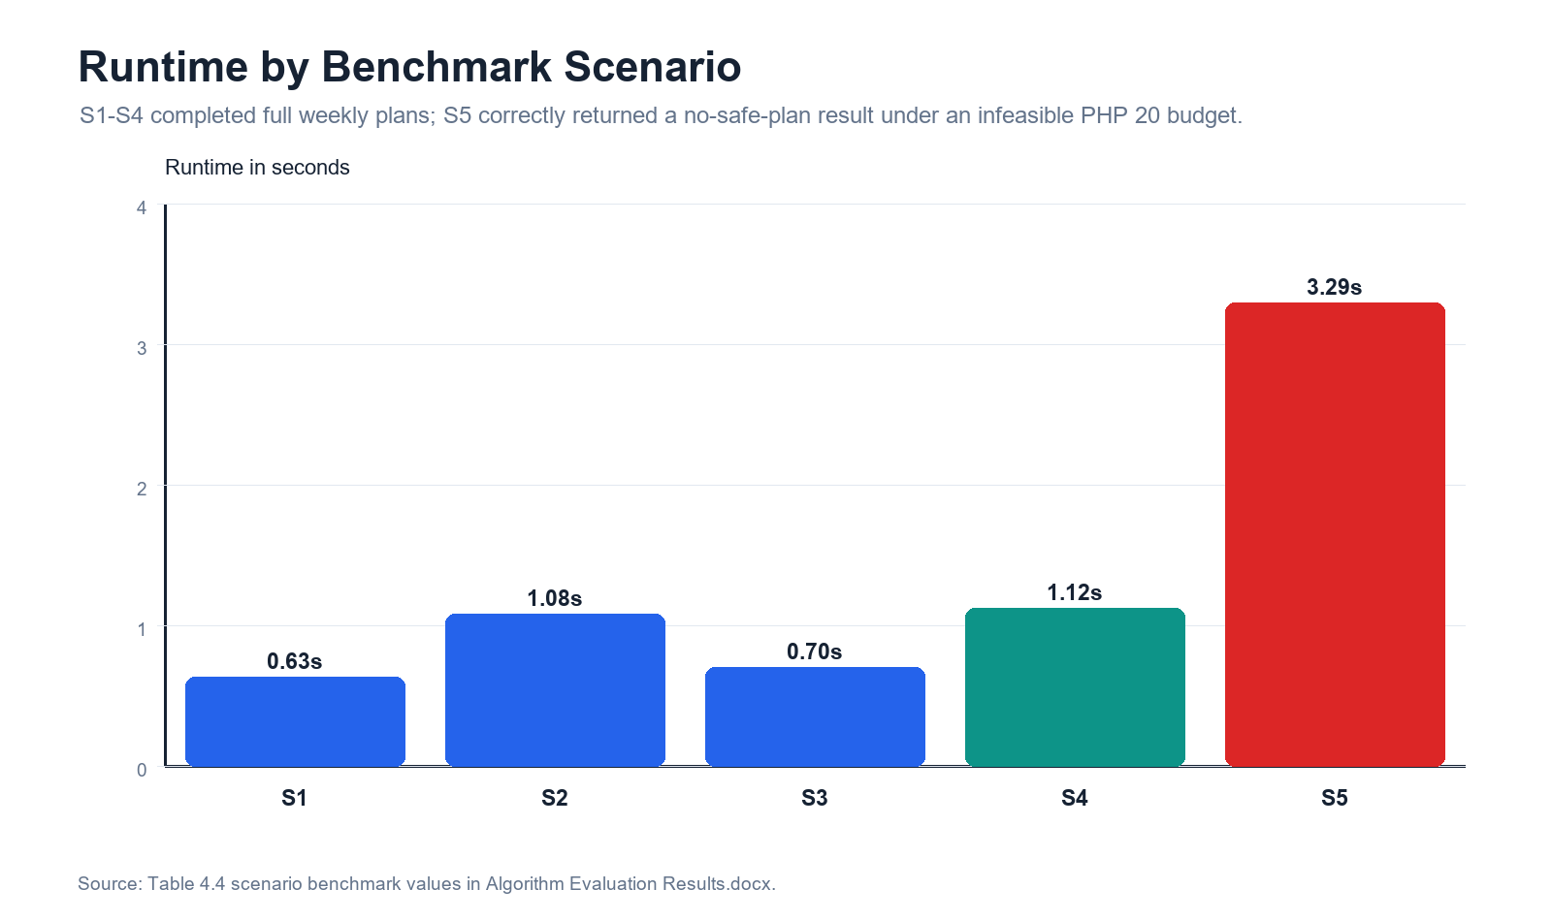
Figure 4.1. Runtime by benchmark scenario. S5 is slower because the solver has to prove infeasibility, but it still fails safely.
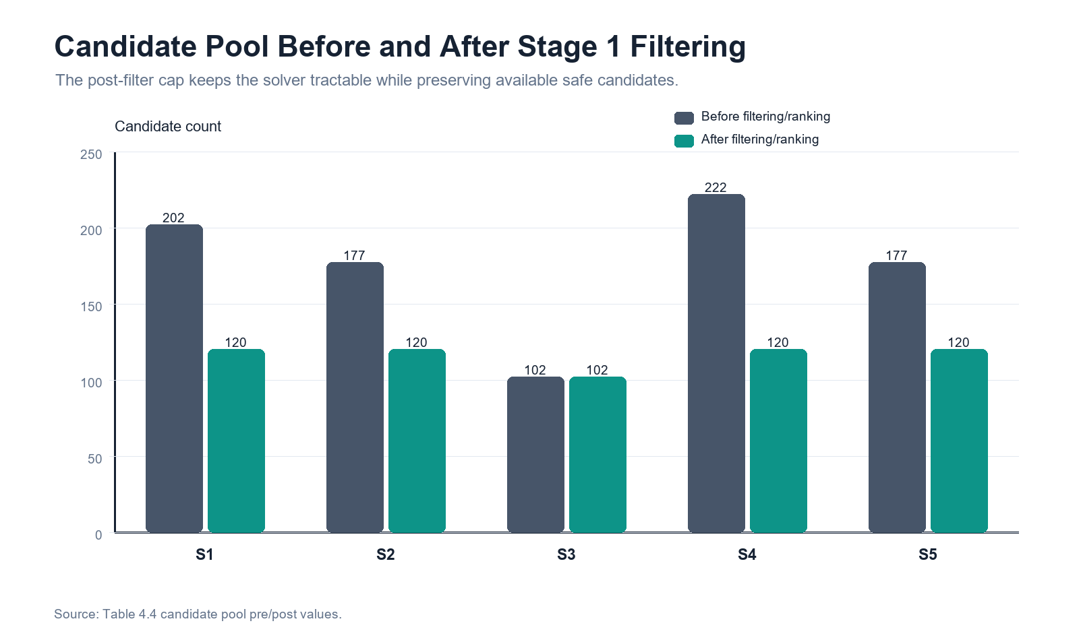
Figure 4.2. Candidate pool before and after Stage 1 filtering/ranking. The post-filter pool keeps CP-SAT search tractable.
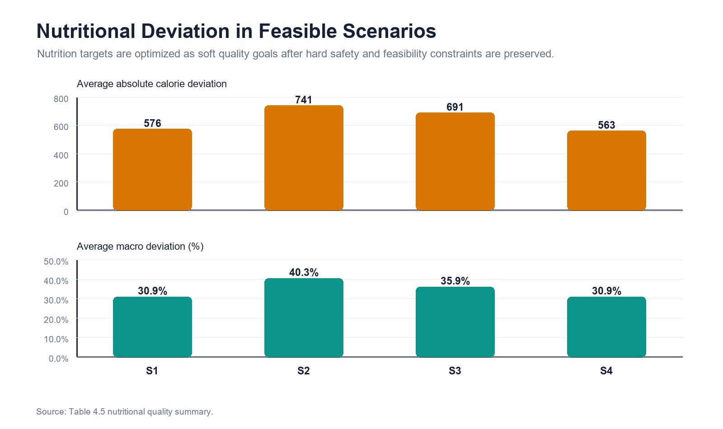
Figure 4.3. Nutritional deviation in feasible scenarios. Nutrition is treated as an optimization quality target after hard constraints are satisfied.
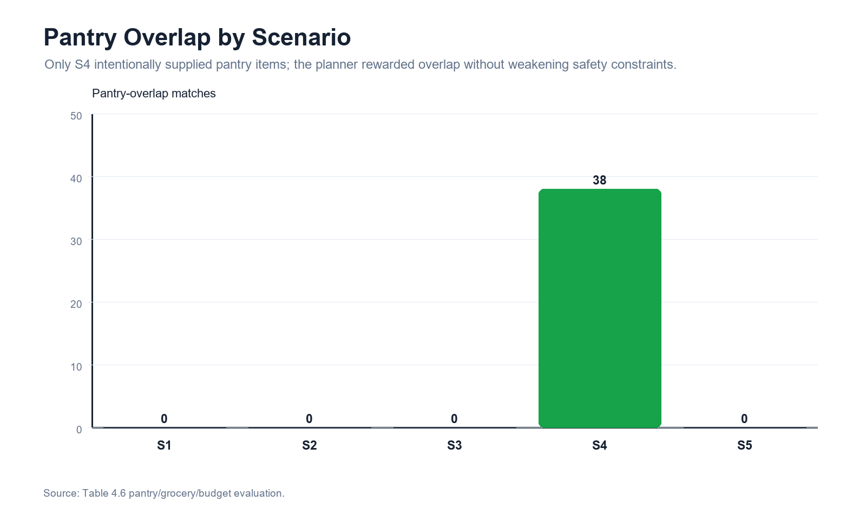
Figure 4.4. Pantry overlap by scenario. The pantry-aware case shows the intended pantry reward without weakening safety rules.
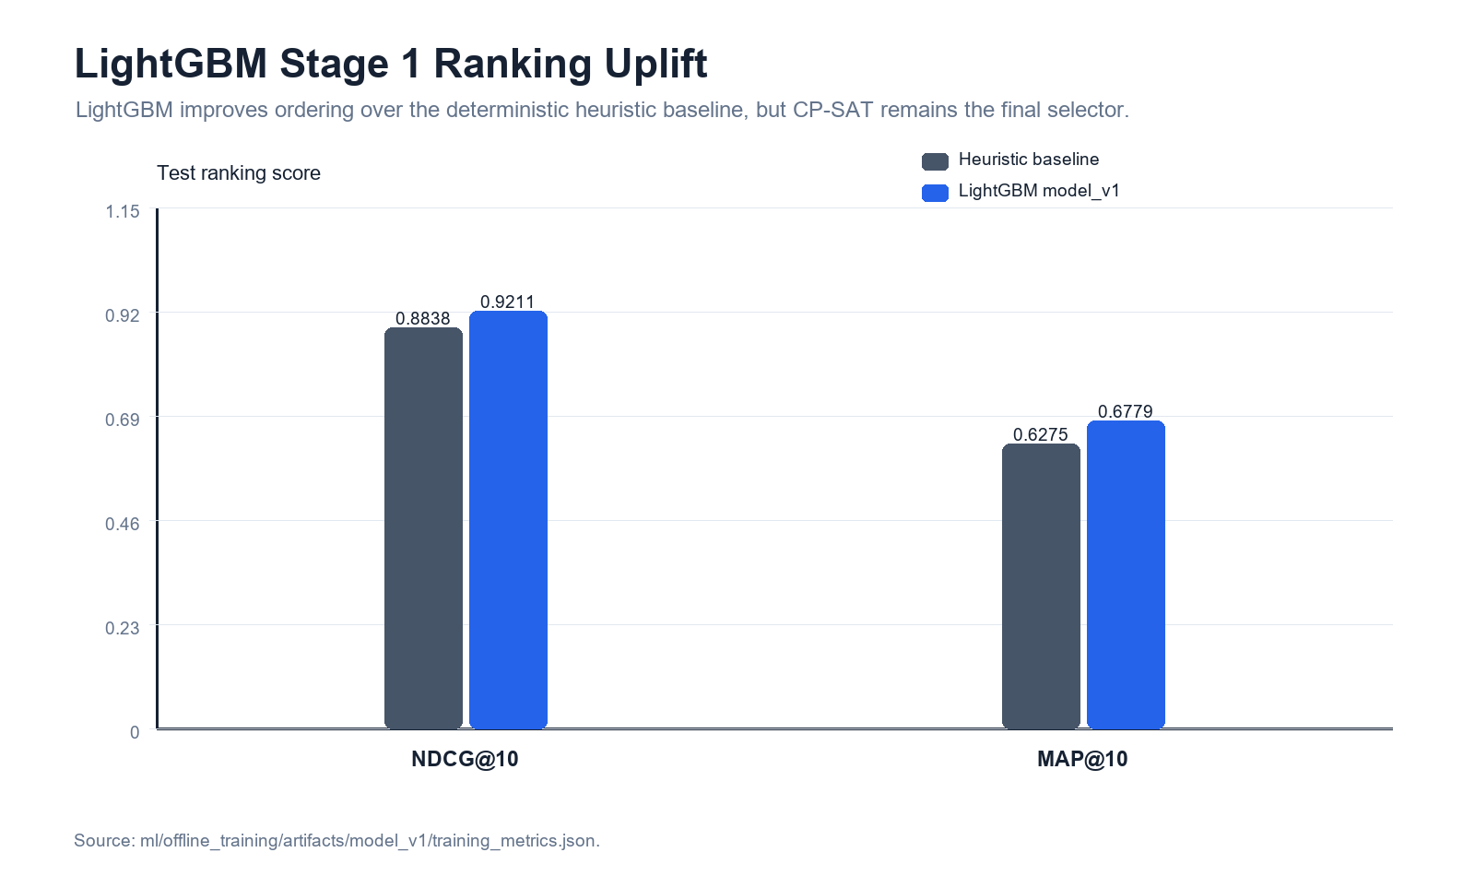
Figure 4.5. LightGBM Stage 1 ranking uplift over the heuristic baseline on the test split.
Table 4.10
Comparison of Candidate Algorithm Choices
Algorithm | Hard-constraint evidence | Runtime and quality signal | Defense interpretation
CP-SAT two-stage | 10 runs; 0.0% hard violation rate | Average runtime 2.2806s; objective surrogate J 0.2236 | Final authority because it performs deterministic filtering plus global constrained assignment and preserves safe failure behavior.
Greedy heuristic | 10 runs; 0.0% hard violation rate | Average runtime 0.2359s; objective surrogate J 0.2248 | Useful as a fast baseline or fallback, but weaker as the main planner because it does not provide the same global optimization framing.
Generative proxy | 100 runs; 100.0% hard violation rate | Average runtime 0.0061s; objective surrogate J 0.3076 | Unsuitable as final authority because the comparison artifact shows hard-constraint violations even though it is fast.
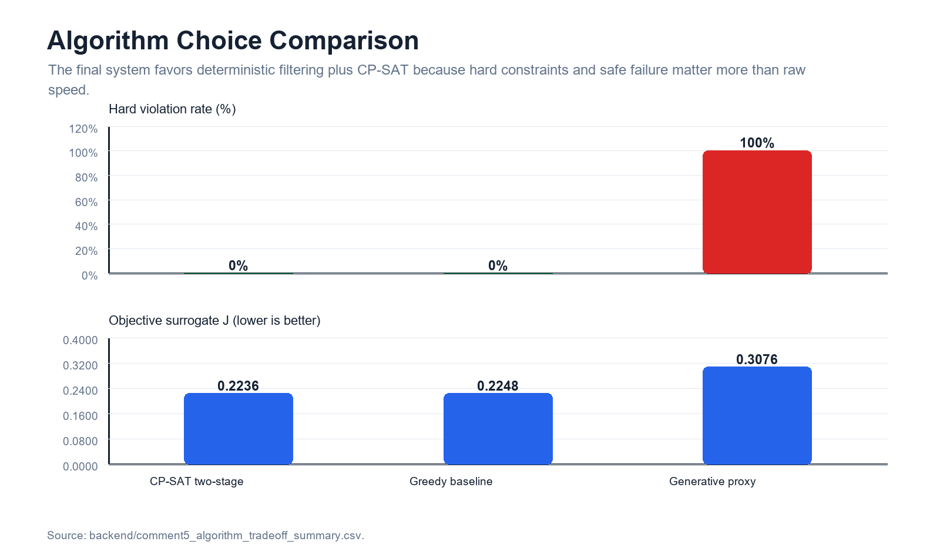
Figure 4.6. Algorithm choice comparison. CP-SAT is retained as the final authority because hard-constraint reliability is more important than raw generation speed.
The comparison does not argue that CP-SAT is always the fastest option. It argues that PCOSina's use case requires predictable constraint handling, auditable no-safe-plan behavior, and reproducible optimization. Greedy ranking can remain a reference or fallback, while LightGBM can assist candidate ordering. Neither replaces the deterministic safety filters or the CP-SAT final assignment.

4.9 Discussion of Findings
The findings indicate that PCOSina achieved the main technical objectives of the study: profile-based data collection, deterministic safety filtering, Stage 1 ranking support, CP-SAT weekly meal-plan optimization, pantry-aware grocery guidance, structured no-safe-plan handling, and offline-first continuity for saved information.
For the algorithmic objective, the final-build local benchmark showed that the planner generated complete 21-slot plans for the ordinary, budget-restricted, combined-dietary-restriction, and pantry-aware scenarios. The same evaluation also showed that an intentionally infeasible budget produced a no-safe-plan result instead of an unsafe plan. This supports the claim that hard constraints remain authoritative in the latest system.
The nutrition results show useful optimization behavior but not perfect target satisfaction. Calorie and macronutrient deviations remained present across completed scenarios, which is expected because the planner balances nutrition targets with cultural recipe availability, budget, pantry overlap, repetition, and dietary restrictions. For this reason, PCOSina should be described as a wellness decision-support system rather than a clinical treatment or diagnosis tool.
The pantry and grocery findings also require careful interpretation. Pantry overlap improved practical planning in the pantry-aware scenario, but the implementation should be described as pantry-aware guidance rather than pantry-only feasibility. Grocery and price outputs are useful planning estimates, not guarantees of exact household inventory coverage or real-time market prices.
The offline-first findings show continuity for saved user-facing data, while new optimized plan generation remains dependent on backend planning availability. This distinction is important because it prevents overclaiming full offline optimization while still supporting the practical value of local persistence.
Overall, Chapter 4 presents system and algorithm evidence rather than clinical outcome evidence. The current results support technical feasibility, hard-constraint safety, practical pantry and budget guidance, ML-assisted ranking readiness, and improved performance, while still requiring final target-environment testing and separate respondent or expert evaluation for usability and acceptance claims.
These findings should be read as implementation and algorithm validation only. They do not claim diagnosis, clinical treatment effect, PCOS symptom improvement, or respondent acceptance; those claims require separate clinical, usability, or expert-evaluation evidence.

